Order Of Lenten Service

Opening Hymn: TLH 166

Reading: Lent VI

The History of the Passion of our Lord

Sermon Hymn: TLH 178

Sermon Text: Daniel 4:10-18

The Great Tree

Prayer

Holy Communion

The Lord's Prayer

The Blessing

Closing Hymn: TLH 179

* * * * * * * * * * * * *

Bible Study: Lambs: Sea Horse
Sheep: Romans 9:30-33

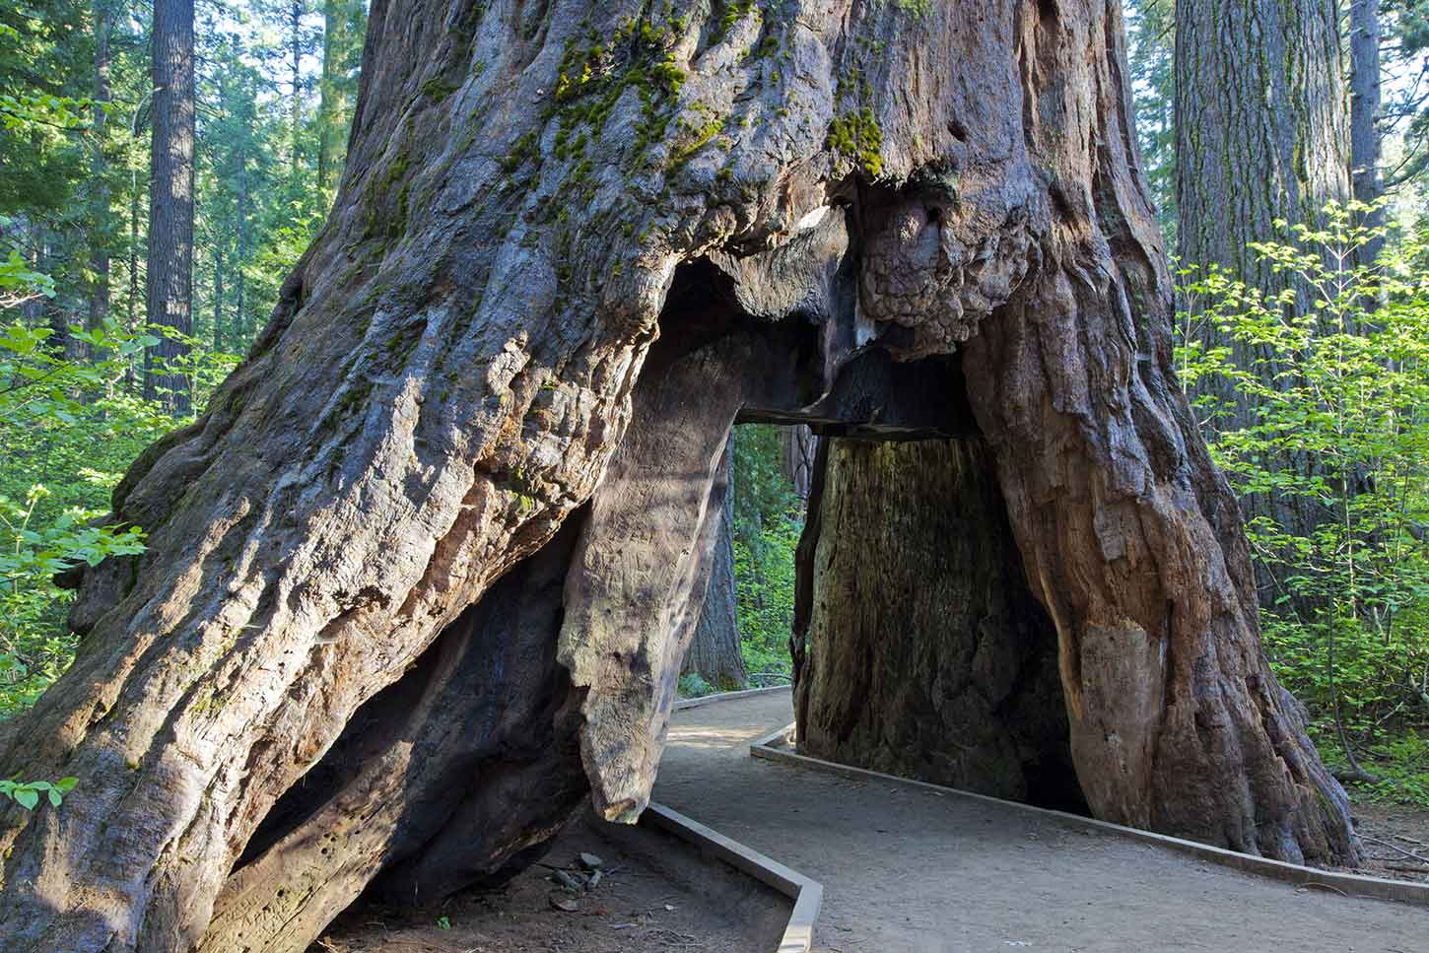

The Great Tree

Water
Of
Life

18 March 2018

W A T E R O F L I F E

Independent Christian Church—Conservative Lutheran Doctrine

Worship Service: 9:30 a.m. Bible Study: 10:45 a.m.

Larry Cooper, Pastor E-Mail address:
111 N. Ridge Road lcooper@wateroflife.cc
Coon Valley, WI 54623 Web Site:
Phone: (608) 452-2105 www.wateroflife.cc

* * * * * * * * * * * * * * * * * * * * * * * * * * *

Sermon Text: Daniel 4:10-18

The Great Tree

* * * * * * * * * * * * * * * * * * * * * * * * * * *

Daniel 4:10 Thus were the visions of mine head in my bed; I saw, and behold a tree in the midst of the earth, and the height thereof was great.
:11 The tree grew, and was strong, and the height thereof reached unto heaven, and the sight thereof to the end of all the earth:
:12 The leaves thereof were fair, and the fruit thereof much, and in it was meat for all: the beasts of the field had shadow under it, and the fowls of the heaven dwelt in the boughs thereof, and all flesh was fed of it.
:13 I saw in the visions of my head upon my bed, and, behold, a watcher and an holy one came down from heaven;
:14 He cried aloud, and said thus, Hew down the tree, and cut off his branches, shake off his leaves, and scatter his fruit: let the beasts get away from under it, and the fowls from his branches:
:15 Nevertheless leave the stump of his roots in the earth, even with a band of iron and brass, in the tender grass of the field; and let it be wet with the dew of heaven, and let his portion be with the beasts in the grass of the earth:
:16 Let his heart be changed from man's, and let a beast's heart be given unto him; and let seven times pass over him.
:17 This matter is by the decree of the watchers, and the demand by the word of the holy ones: to the intent that the living may know that the most High ruleth in the kingdom of men, and giveth it to whomsoever he will, and setteth up over it the basest of men.
:18 This dream I king Nebuchadnezzar have seen. Now thou, O Belteshazzar, declare the interpretation thereof, forasmuch as all the wise men of my kingdom are not able to make known unto me the interpretation: but thou art able; for the spirit of the holy gods is in thee.

